20250219 kinetics mode re-commissioning with new PIMAX4

Lightfield experiment 2025-1_PIMAX-kinitic_setup

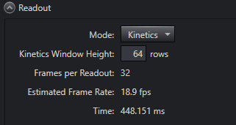

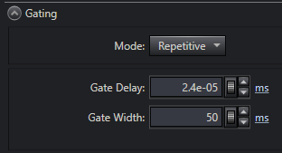

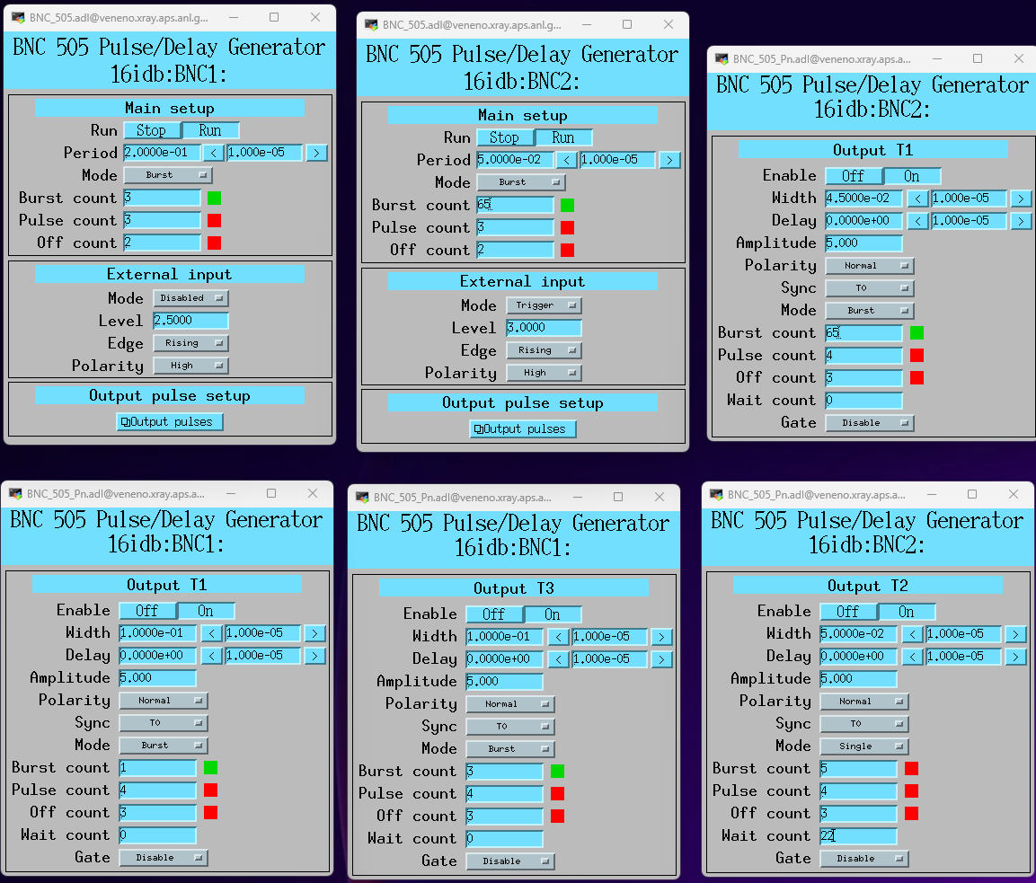

T2 is connected to trigger the function generator.

Setting the function generator to output 1 pulse in only one kinetic shift window to test the syncing

First frame where we see both Dn and Up is with Wait count 22 on T2

the last frame seen on both Dn and Up is with wait count 54

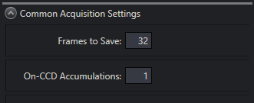

For some reason have to send out 64 pulses to the pixis to save 32 frames

to avoid having to double the number of pulses we need to set the gate width for pimax4 to be 4ms less than the shift period. For example shift period 50ms, gate width 46ms.

This seems to be the time it takes this pimax to shift one frame

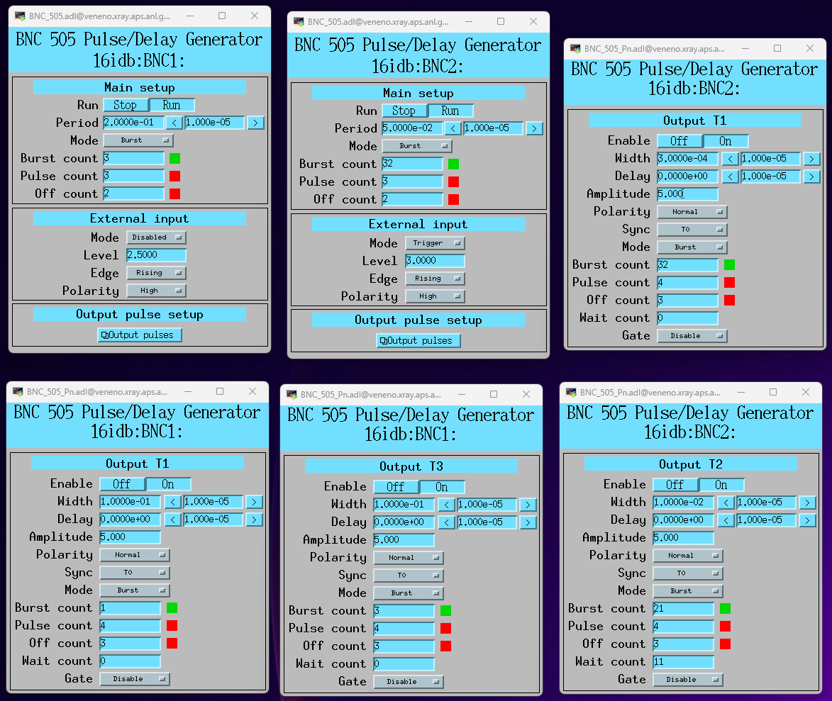

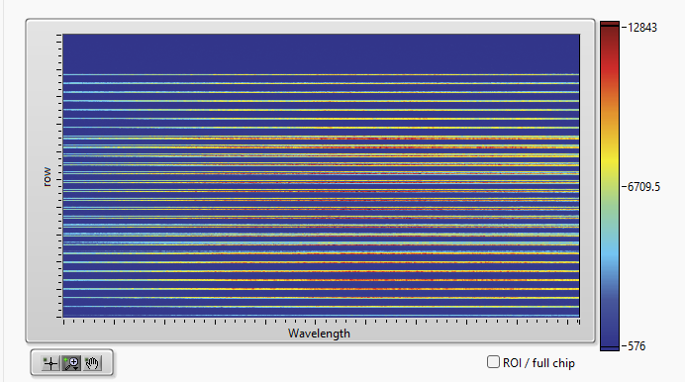

Last frame, because older frames get shifted down chip